Regular Expression
Prepared: TrangNTT
Lab 7. Regular Expression 1
7.1. Open workspace and Create Folder 2
7.2. Product Information Request 3
7.3. Date Validation 5
7.4. Modify 12.3 to fully check a valid date 6
7.5. Exercise 6

Prepare
Create Lab7 directory in the lab exercise project.

Product Information Request

ProductRequest.html
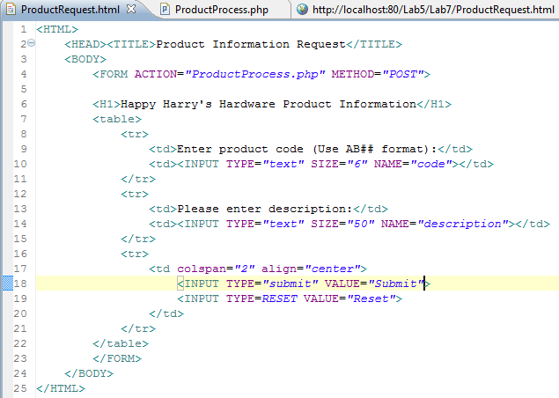

ProductProcess.php
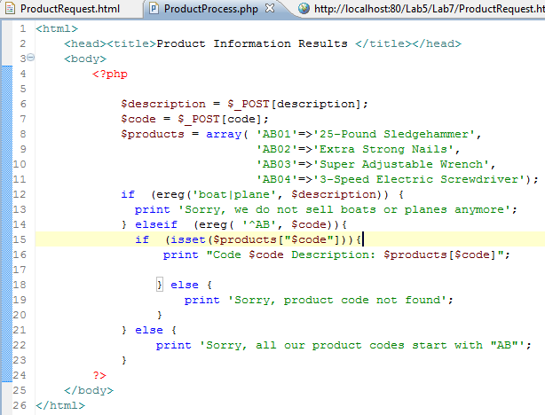

Run
1)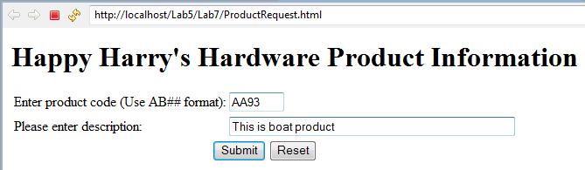

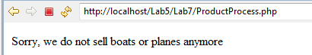
2)
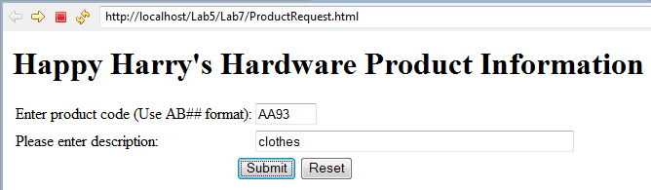

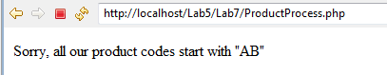
3)
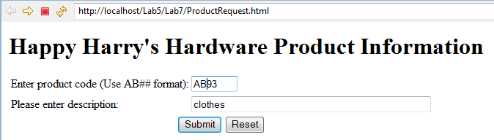
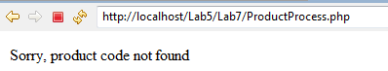
4)
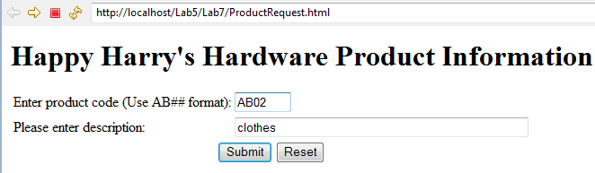

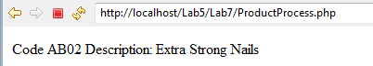

Date Validation

CheckDate.html
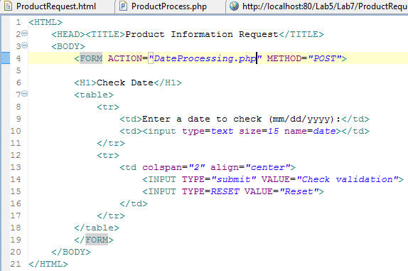

DateProcessing.php
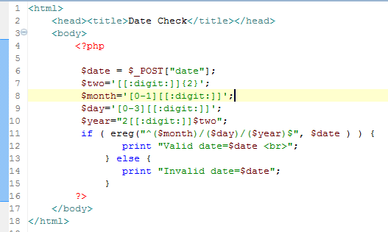

Run
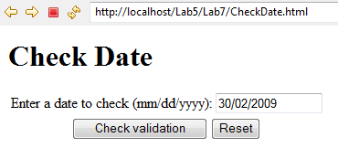

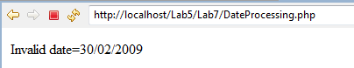

Modify 12.3 to fully check a valid date

Exercise
            - Compare the preg_match() function with ereg() funtion; preg_replace() function with ereg_replace() function.
            - Write a web page to input and validate the followings using regular expressions:
- Email address
- URL address
- Phone number

